**BASDA Utilities Extension XML Guide Line**

|  |  |
| --- | --- |
| **Full Path** | MeterPointData |
| **Element** | *MeterPointData* |

|  |  |  |  |  |  |
| --- | --- | --- | --- | --- | --- |
| **Relationship with Parent** | Dependant on location | **Data Type** | Complex | **Mandatory or Optional** | O |

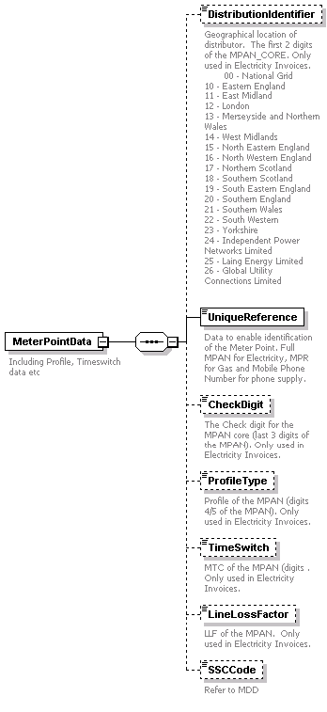

**Description**

Data to enable identification of the Meter Point. Full MPAN for Electricity, MPR for Gas and Mobile Phone Number for phone supply.

**Attributes**

**Code List**

**Example**

**Notes**

|  |  |
| --- | --- |
| **Full Path** | MeterPointData\DistributionIdentifier |
| **Element** | *DistributionIdentifier* |

|  |  |  |  |  |  |
| --- | --- | --- | --- | --- | --- |
| **Relationship with Parent** | Zero-One | **Data Type** | Integer | **Mandatory or Optional** | O |

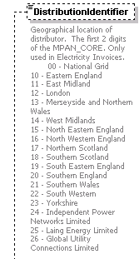

**Description**

Geographical location of distributor. The first 2 digits of the MPAN_CORE. Only used in Electricity Invoices.

**Attributes**

**Code List**

**00 - National Grid**

**10 - Eastern England**

**11 - East Midland**

**12 - London**

**13 - Merseyside and Northern Wales**

**14 - West Midlands**

**15 - North Eastern England**

**16 - North Western England**

**17 - Northern Scotland**

**18 - Southern Scotland**

**19 - South Eastern England**

**20 - Southern England**

**21 - Southern Wales**

**22 - South Western**

**23 - Yorkshire**

**24 - Independent Power Networks Limited**

**25 - Laing Energy Limited**

**26 - Global Utility Connections Limited**

**Example**

<DistributionIdentifier>12</DistributionIdentifier>

**Notes**

|  |  |
| --- | --- |
| **Full Path** | MeterPointData\UniqueReference |
| **Element** | *UniqueReference* |

|  |  |  |  |  |  |
| --- | --- | --- | --- | --- | --- |
| **Relationship with Parent** | One-One | **Data Type** | Integer | **Mandatory or Optional** | M |

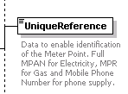

**Description**

Unique number for MPAN (digits 12-19 of the MPAN), or MPR for Gas meters. Mobile Phone Number for phones.

**Attributes**

**Code List**

**Example**

<UniqueReference>34567890</UniqueReference>

**Notes**

|  |  |
| --- | --- |
| **Full Path** | MeterPointData\CheckDigit |
| **Element** | *CheckDigit* |

|  |  |  |  |  |  |
| --- | --- | --- | --- | --- | --- |
| **Relationship with Parent** | Zero-One | **Data Type** | Integer | **Mandatory or Optional** | O |

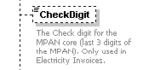

**Description**

The Check digit for the MPAN core (last 3 digits of the MPAN). Only used in Electricity Invoices.

**Attributes**

**Code List**

**Example**

<CheckDigit>126</CheckDigit>

**Notes**

|  |  |
| --- | --- |
| **Full Path** | MeterPointData\ProfileType |
| **Element** | *ProfileType* |

|  |  |  |  |  |  |
| --- | --- | --- | --- | --- | --- |
| **Relationship with Parent** | Zero-One | **Data Type** | Integer | **Mandatory or Optional** | O |

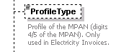

**Description**

Profile of the MPAN (digits 4/5 of the MPAN). Only used in Electricity Invoices.

**Attributes**

**Code List**

**00 Half hourly metered**

**01 Domestic Single Rate**

**02 Domestic Two Rate**

**03 Non-Domestic Single Rate**

**04 Non-Domestic Multi-rate**

**05 Non-Domestic Maximum Demand Load Factor Bnd 0-20%**

**06 Non-Domestic Maximum Demand Load Factor Bnd 20-30%**

**07 Non-Domestic Maximum Demand Load Factor Bnd 30-40%**

**08 Non-Domestic Maximum Demand Load Factor Bnd > 40%**

**Example**

<ProfileType>03</ProfileType>

**Notes**

|  |  |
| --- | --- |
| **Full Path** | MeterPointData\TimeSwitch |
| **Element** | *TimeSwitch* |

|  |  |  |  |  |  |
| --- | --- | --- | --- | --- | --- |
| **Relationship with Parent** | Zero-One | **Data Type** | String | **Mandatory or Optional** | O |

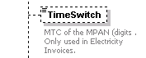

**Description**

MTC of the MPAN (digits . Only used in Electricity Invoices.

**Attributes**

**Code List**

**Example**

<TimeSwitch>501</TimeSwitch>

**Notes**

|  |  |
| --- | --- |
| **Full Path** | MeterPointData\LineLossFactor |
| **Element** | *LineLossFactor* |

|  |  |  |  |  |  |
| --- | --- | --- | --- | --- | --- |
| **Relationship with Parent** | Zero-One | **Data Type** | String | **Mandatory or Optional** | O |

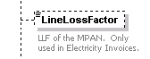

**Description**

LLF of the MPAN. Only used in Electricity Invoices.

**Attributes**

**Code List**

**Example**

<LineLossFactor>045</LineLossFactor>

**Notes**

|  |  |
| --- | --- |
| **Full Path** | MeterPointData\SSCCode |
| **Element** | *SSCCode* |

|  |  |  |  |  |  |
| --- | --- | --- | --- | --- | --- |
| **Relationship with Parent** | Zero-One | **Data Type** | String | **Mandatory or Optional** | O |



**Description**

**Attributes**

**Code List**

Refer to MDD

**Example**

<SSCCode>0001</SSCCode>

**Notes**

|  |  |
| --- | --- |
| **Full Path** | SiteInvoice |
| **Element** |  |

|  |  |  |  |  |  |
| --- | --- | --- | --- | --- | --- |
| **Relationship with Parent** |  | **Data Type** | Complex | **Mandatory or Optional** | M |

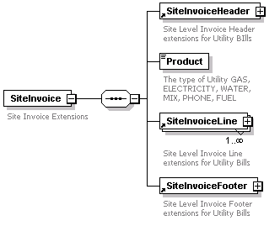

**Description**

**Attributes**

**Code List**

**Example**

**Notes**

|  |  |
| --- | --- |
| **Full Path** | SiteInvoiceHeader |
| **Element** | *SiteInvoiceHeader* |

|  |  |  |  |  |  |
| --- | --- | --- | --- | --- | --- |
| **Relationship with Parent** | One-One | **Data Type** | Complex | **Mandatory or Optional** | M |

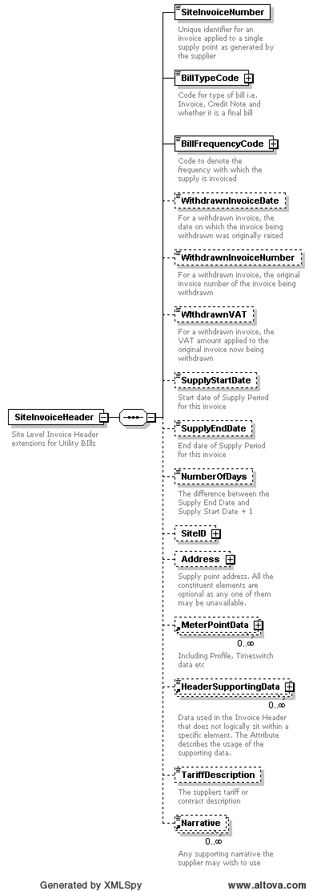

**Description**

Invoice header information

**Attributes**

**Code List**

**Example**

**Notes**

|  |  |
| --- | --- |
| **Full Path** | SiteInvoiceHeader\SiteInvoiceNumber |
| **Element** | *SiteInvoiceNumber* |

|  |  |  |  |  |  |
| --- | --- | --- | --- | --- | --- |
| **Relationship with Parent** | One-One | **Data Type** | String | **Mandatory or Optional** | M |

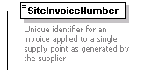

**Description**

Unique identifier for an invoice applied to a single supply point as generated by the supplier

**Attributes**

**Code List**

**Example**

**Notes**

|  |  |
| --- | --- |
| **Full Path** | SiteInvoiceHeader\BillTypeCode |
| **Element** | *BillTypeCode* |

|  |  |  |  |  |  |
| --- | --- | --- | --- | --- | --- |
| **Relationship with Parent** | One-One | **Data Type** | String | **Mandatory or Optional** | M |

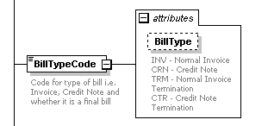

**Description**

Code for type of bill i.e. Invoice, Credit Note and whether it is a final bill

**Attributes**

BillType

**Code List**

**INV - Normal Invoice**

**CRN - Credit Note**

**TRM - Normal Invoice Termination**

CTR - Credit Note Termination

**Example**

**Notes**

|  |  |
| --- | --- |
| **Full Path** | SiteInvoiceHeader\BillFrequencyCode |
| **Element** | *BillFrequencyCode* |

|  |  |  |  |  |  |
| --- | --- | --- | --- | --- | --- |
| **Relationship with Parent** | One-One | **Data Type** | String | **Mandatory or Optional** | M |

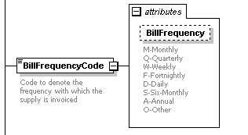

**Description**

Code to denote the frequency with which the supply is invoiced

**Attributes**

BillFrequency

**Code List**

**M-Monthly**

**Q-Quarterly**

**W-Weekly**

**F-Fortnightly**

**D-Daily**

**S-Six-Monthly**

**A-Annual**

**O-Other**

**Example**

**Notes**

|  |  |
| --- | --- |
| **Full Path** | SiteInvoiceHeader\WithdrawnInvoiceDate |
| **Element** | *WithdrawnInvoiceDate* |

|  |  |  |  |  |  |
| --- | --- | --- | --- | --- | --- |
| **Relationship with Parent** | Zero-One | **Data Type** | Date | **Mandatory or Optional** | O |

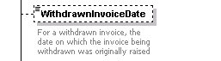

**Description**

For a withdrawn invoice, the date on which the invoice being withdrawn was originally raised

**Attributes**

**Code List**

**Example**

**Notes**

|  |  |
| --- | --- |
| **Full Path** | SiteInvoiceHeader\WithdrawnInvoiceNumber |
| **Element** | *WithdrawnInvoiceNumber* |

|  |  |  |  |  |  |
| --- | --- | --- | --- | --- | --- |
| **Relationship with Parent** | Zero-One | **Data Type** | String | **Mandatory or Optional** | O |

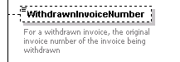

**Description**

For a withdrawn invoice, the original invoice number of the invoice being withdrawn

**Attributes**

**Code List**

**Example**

**Notes**

|  |  |
| --- | --- |
| **Full Path** | SiteInvoiceHeader\WIthdrawnVAT |
| **Element** | *WIthdrawnVAT* |

|  |  |  |  |  |  |
| --- | --- | --- | --- | --- | --- |
| **Relationship with Parent** | Zero-One | **Data Type** | Decimal | **Mandatory or Optional** | O |

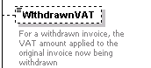

**Description**

For a withdrawn invoice, the VAT amount applied to the original invoice now being withdrawn

**Attributes**

**Code List**

**Example**

**Notes**

|  |  |
| --- | --- |
| **Full Path** | SiteInvoiceHeader\SupplyStartDate |
| **Element** | *SupplyStartDate* |

|  |  |  |  |  |  |
| --- | --- | --- | --- | --- | --- |
| **Relationship with Parent** | Zero-One | **Data Type** | Date | **Mandatory or Optional** | O |



**Description**

Start date of Supply Period for this invoice

**Attributes**

**Code List**

**Example**

**Notes**

|  |  |
| --- | --- |
| **Full Path** | SiteInvoiceHeader\SupplyEndDate |
| **Element** | *SupplyEndDate* |

|  |  |  |  |  |  |
| --- | --- | --- | --- | --- | --- |
| **Relationship with Parent** | Zero-One | **Data Type** | Date | **Mandatory or Optional** | O |

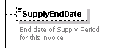

**Description**

End date of Supply Period for this invoice

**Attributes**

**Code List**

**Example**

**Notes**

|  |  |
| --- | --- |
| **Full Path** | SiteInvoiceHeader\NumberOfDays |
| **Element** | *NumberOfDays* |

|  |  |  |  |  |  |
| --- | --- | --- | --- | --- | --- |
| **Relationship with Parent** | Zero-One | **Data Type** | Integer | **Mandatory or Optional** | O |

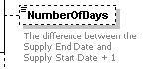

**Description**

The difference between the Supply End Date and Supply Start Date + 1

**Attributes**

**Code List**

**Example**

**Notes**

|  |  |
| --- | --- |
| **Full Path** | SiteInvoiceHeader/SiteID |
| **Element** | *SiteID* |

|  |  |  |  |  |  |
| --- | --- | --- | --- | --- | --- |
| **Relationship with Parent** | Zero-One | **Data Type** | Complex | **Mandatory or Optional** | O |

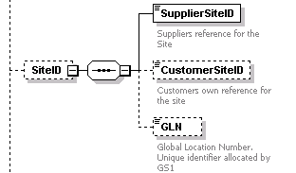

**Description**

References which identify the supply point.

**Attributes**

**Code List**

**Example**

**Notes**

|  |  |
| --- | --- |
| **Full Path** | SiteInvoiceHeader/SiteID/SupplierSiteID |
| **Element** | *SupplierSiteID* |

|  |  |  |  |  |  |
| --- | --- | --- | --- | --- | --- |
| **Relationship with Parent** | One-One | **Data Type** | String | **Mandatory or Optional** | M |

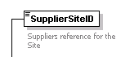

**Description**

Suppliers reference for the Site.

**Attributes**

**Code List**

**Example**

**Notes**

|  |  |
| --- | --- |
| **Full Path** | SiteInvoiceHeader/SiteID/CustomerSiteID |
| **Element** | *CustomerSiteID* |

|  |  |  |  |  |  |
| --- | --- | --- | --- | --- | --- |
| **Relationship with Parent** | Zero-One | **Data Type** | String | **Mandatory or Optional** | O |

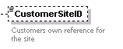

**Description**

Customer's reference for the Site.

**Attributes**

**Code List**

**Example**

**Notes**

|  |  |
| --- | --- |
| **Full Path** | SiteInvoiceHeader/SiteID/GLN |
| **Element** | *GLN* |

|  |  |  |  |  |  |
| --- | --- | --- | --- | --- | --- |
| **Relationship with Parent** | Zero-One | **Data Type** | Integer | **Mandatory or Optional** | O |

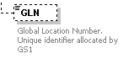

**Description**

Global Location Number. Unique identifier allocated by GS1

**Attributes**

**Code List**

**Example**

**Notes**

|  |  |
| --- | --- |
| **Full Path** | SiteInvoiceHeader/Address |
| **Element** | *Address* |

|  |  |  |  |  |  |
| --- | --- | --- | --- | --- | --- |
| **Relationship with Parent** | Zero-One | **Data Type** | Complex | **Mandatory or Optional** | O |

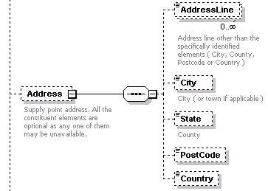

**Description**

Supply point address. All the constituent elements are optional as any one of them may be unavailable.

**Attributes**

**Code List**

**Example**

**Notes**

|  |  |
| --- | --- |
| **Full Path** | SiteInvoiceHeader/Address/AddressLine |
| **Element** | *AddressLine* |

|  |  |  |  |  |  |
| --- | --- | --- | --- | --- | --- |
| **Relationship with Parent** | Zero-Many | **Data Type** | String | **Mandatory or Optional** | O |

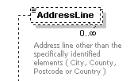

**Description**

Address line other than the specifically identified elements ( City, County, Postcode or Country )

**Attributes**

**Code List**

**Example**

**Notes**

|  |  |
| --- | --- |
| **Full Path** | SiteInvoiceHeader/Address/City |
| **Element** | *City* |

|  |  |  |  |  |  |
| --- | --- | --- | --- | --- | --- |
| **Relationship with Parent** | Zero-One | **Data Type** | String | **Mandatory or Optional** | O |



**Description**

City ( or town if applicable )

**Attributes**

**Code List**

**Example**

**Notes**

|  |  |
| --- | --- |
| **Full Path** | SiteInvoiceHeader/Address/State |
| **Element** | *State* |

|  |  |  |  |  |  |
| --- | --- | --- | --- | --- | --- |
| **Relationship with Parent** | Zero-One | **Data Type** | String | **Mandatory or Optional** | O |



**Description**

County

**Attributes**

**Code List**

**Example**

**Notes**

|  |  |
| --- | --- |
| **Full Path** | SiteInvoiceHeader/Address/PostCode |
| **Element** | *Postcode* |

|  |  |  |  |  |  |
| --- | --- | --- | --- | --- | --- |
| **Relationship with Parent** | Zero-One | **Data Type** | String | **Mandatory or Optional** | O |



**Description**

Postcode

**Attributes**

**Code List**

**Example**

**Notes**

|  |  |
| --- | --- |
| **Full Path** | SiteInvoiceHeader/Address/Country |
| **Element** | *Country* |

|  |  |  |  |  |  |
| --- | --- | --- | --- | --- | --- |
| **Relationship with Parent** | Zero-One | **Data Type** |  | **Mandatory or Optional** | O |



**Description**

Country

**Attributes**

**Code List**

**Example**

**Notes**

|  |  |
| --- | --- |
| **Full Path** | SiteInvoiceHeader\HeaderSupportingData |
| **Element** | *HeaderSupportingData* |

|  |  |  |  |  |  |
| --- | --- | --- | --- | --- | --- |
| **Relationship with Parent** | Zero-many | **Data Type** | String | **Mandatory or Optional** | O |

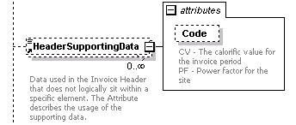

**Description**

Data used in the Invoice Header that does not logically sit within a specific element. The Attribute describes the usage of the supporting data.

**Attributes**

Code

**Code List**

**CV - The calorific value for the invoice period**

PF - Power factor for the site

**Example**

<HeaderSupportingData Code="PF">0.9844</HeaderSupportingData>

**Notes**

|  |  |
| --- | --- |
| **Full Path** | SiteInvoiceHeader\TariffDescription |
| **Element** | *TariffDescription* |

|  |  |  |  |  |  |
| --- | --- | --- | --- | --- | --- |
| **Relationship with Parent** | zero-one | **Data Type** | String | **Mandatory or Optional** | O |



**Description**

The suppliers tariff or contract description

**Attributes**

**Code List**

**Example**

<TariffDescription>Economy 7 Super Saver</TariffDescription>

**Notes**

|  |  |
| --- | --- |
| **Full Path** | SiteInvoiceHeader\Narrative |
| **Element** | *Narrative* |

|  |  |  |  |  |  |
| --- | --- | --- | --- | --- | --- |
| **Relationship with Parent** | Zero-many | **Data Type** | String | **Mandatory or Optional** | O |



**Description**

Any supporting narrative the supplier may wish to use

**Attributes**

**Code List**

**Example**

<Narrative>To receive more accurate bills did you know you can enter your readings online?</Narrative>

**Notes**

|  |  |
| --- | --- |
| **Full Path** | Product |
| **Element** | *Product* |

|  |  |  |  |  |  |
| --- | --- | --- | --- | --- | --- |
| **Relationship with Parent** | One-One | **Data Type** | String | **Mandatory or Optional** | M |



**Description**

The type of Utility

**Attributes**

**Code List**

GAS, ELECTRICITY, WATER, MIX, PHONE, FUEL

**Example**

<Product>GAS</Product>

**Notes**

|  |  |
| --- | --- |
| **Full Path** | SiteInvoiceLine |
| **Element** | *SiteInvoiceLine* |

|  |  |  |  |  |  |
| --- | --- | --- | --- | --- | --- |
| **Relationship with Parent** | one-many | **Data Type** | Complex | **Mandatory or Optional** | M |

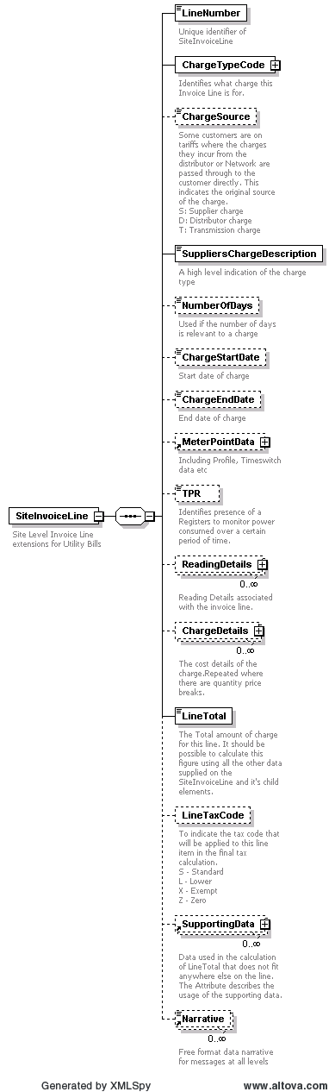

**Description**

Chargeable component of a bill. Each separate charge will have it's own SiteInvoiceLine

**Attributes**

**Code List**

**Example**

**Notes**

|  |  |
| --- | --- |
| **Full Path** | SiteInvoiceLine\LineNumber |
| **Element** | *LineNumber* |

|  |  |  |  |  |  |
| --- | --- | --- | --- | --- | --- |
| **Relationship with Parent** | one-many | **Data Type** | Integer | **Mandatory or Optional** | M |

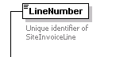

**Description**

Unique identifier of SiteInvoiceLine

**Attributes**

**Code List**

**Example**

<LineNumber>1</LineNumber>

**Notes**

|  |  |
| --- | --- |
| **Full Path** | SiteInvoiceLine\ChargeTypeCode |
| **Element** | *ChargeTypeCode* |

|  |  |  |  |  |  |
| --- | --- | --- | --- | --- | --- |
| **Relationship with Parent** | one-one | **Data Type** | Complex | **Mandatory or Optional** | M |

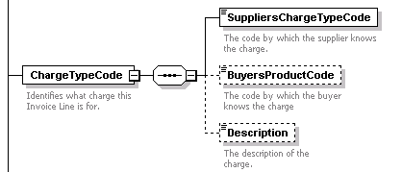

**Description**

Identifies what charge this Invoice Line is for.

**Attributes**

**Code List**

**Example**

**Notes**

|  |  |
| --- | --- |
| **Full Path** | SiteInvoiceLine\ChargeTypeCode\SuppliersChargeTypeCode |
| **Element** | *SuppliersChargeTypeCode* |

|  |  |  |  |  |  |
| --- | --- | --- | --- | --- | --- |
| **Relationship with Parent** | one-one | **Data Type** | String | **Mandatory or Optional** | M |



**Description**

The code by which the supplier knows the charge.

**Attributes**

**Code List**

**Example**

<SuppliersChargeTypeCode>DAYRATE</SuppliersChargeTypeCode>

**Notes**

|  |  |
| --- | --- |
| **Full Path** | SiteInvoiceLine\ChargeTypeCode\BuyersProductCode |
| **Element** | *BuyersProductCode* |

|  |  |  |  |  |  |
| --- | --- | --- | --- | --- | --- |
| **Relationship with Parent** | Zero-One | **Data Type** | String | **Mandatory or Optional** | O |



**Description**

The code by which the buyer knows the charge

**Attributes**

**Code List**

**Example**

<BuyersChargeTypeCode>DAY</BuyersChargeTypeCode>

**Notes**

|  |  |
| --- | --- |
| **Full Path** | SiteInvoiceLine\ChargeTypeCode\Description |
| **Element** | *Description* |

|  |  |  |  |  |  |
| --- | --- | --- | --- | --- | --- |
| **Relationship with Parent** | Zero-One | **Data Type** | String | **Mandatory or Optional** | O |

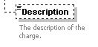

**Description**

The description of the charge.

**Attributes**

**Code List**

**Example**

<Description>KWh used during the day</Description>

**Notes**

|  |  |
| --- | --- |
| **Full Path** | SiteInvoiceLine\ChargeSource |
| **Element** | *ChargeSource* |

|  |  |  |  |  |  |
| --- | --- | --- | --- | --- | --- |
| **Relationship with Parent** | Zero-One | **Data Type** | String | **Mandatory or Optional** | O |

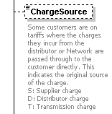

**Description**

Some customers are on tariffs where the charges they incur from the distributor or Network are passed through to the customer directly. This indicates the original source of the charge.

**Attributes**

**Code List**

**S: Supplier charge**

**D: Distributor charge**

T: Transmission charge

**Example**

<ChargeSource>S</ChargeSource>

**Notes**

|  |  |
| --- | --- |
| **Full Path** | SiteInvoiceLine\SuppliersChargeDescription |
| **Element** | *SuppliersChargeDescription* |

|  |  |  |  |  |  |
| --- | --- | --- | --- | --- | --- |
| **Relationship with Parent** | one-one | **Data Type** | String | **Mandatory or Optional** | M |



**Description**

A high level indication of the charge type

**Attributes**

**Code List**

**PENALTY: These include Late Payment Interest, One-Off collection fees for unpaid invoices, Charges for contract breaches.**

**SD: Security Deposit Interest & Tax**

**MISC: Miscellaneous charge item, no specific reason**

**UNITS: Normal KWH Usage**

**ADJ: Adjustment for previous bill**

**REAP: Reactive Power Charges**

**MD: Maximum Demand Charges**

**CAP: Capacity Charge**

**TRIAD: Triad Charges, both the monthly estimate and the final reconciliation charge once the actual 3 MDs are known**

**UMS: Unmetered Supply Usage**

**STDG: Standing Charges**

**METER: These include the following**

HH Data aggragator, HH Data Collection, AMR or non-AMR charges, Meter operator charges, Metering system charges, Communications charges, Data services charges, Settlement agency fees

**Example**

<SuppliersChargeDescription>PENALTY</SuppliersChargeDescription>

**Notes**

|  |  |
| --- | --- |
| **Full Path** | SiteInvoiceLine\NumberOfDays |
| **Element** | *NumberOfDays* |

|  |  |  |  |  |  |
| --- | --- | --- | --- | --- | --- |
| **Relationship with Parent** | Zero-one | **Data Type** | Integer | **Mandatory or Optional** | O |



**Description**

Used if the number of days is relevant to a charge

**Attributes**

**Code List**

**Example**

<NumberOfDays>23</NumberOfDays>

**Notes**

|  |  |
| --- | --- |
| **Full Path** | SiteInvoiceLine\ChargeStartDate |
| **Element** | *ChargeStartDate* |

|  |  |  |  |  |  |
| --- | --- | --- | --- | --- | --- |
| **Relationship with Parent** | Zero-one | **Data Type** | Date | **Mandatory or Optional** | O |



**Description**

Start date of charge

**Attributes**

**Code List**

**Example**

<ChargeStartDate>2011-06-15</ChargeStartDate>

**Notes**

|  |  |
| --- | --- |
| **Full Path** | SiteInvoiceLine\ChargeEndDate |
| **Element** | *ChargeEndDate* |

|  |  |  |  |  |  |
| --- | --- | --- | --- | --- | --- |
| **Relationship with Parent** | Zero-one | **Data Type** | Date | **Mandatory or Optional** | O |



**Description**

End date of charge

**Attributes**

**Code List**

**Example**

<ChargeEndDate>2011-06-30</ChargeEndDate>

**Notes**

|  |  |
| --- | --- |
| **Full Path** | SiteInvoiceLine\MeterPointData |
| **Element** | *MeterPointData* |

|  |  |  |  |  |  |
| --- | --- | --- | --- | --- | --- |
| **Relationship with Parent** | Zero-One | **Data Type** | Complex | **Mandatory or Optional** | O |



**Description**

Meter Point Data

**Attributes**

**Code List**

**Example**

**Notes**

|  |  |
| --- | --- |
| **Full Path** | SiteInvoiceLine\TPR |
| **Element** | *TPR* |

|  |  |  |  |  |  |
| --- | --- | --- | --- | --- | --- |
| **Relationship with Parent** | Zero-One | **Data Type** | String | **Mandatory or Optional** | O |

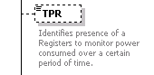

**Description**

Identifies presence of a Registers to monitor power consumed over a certain period of time.

**Attributes**

**Code List**

**Example**

<TimePeriodRegister>01<TimePeriodRegister>

**Notes**

|  |  |
| --- | --- |
| **Full Path** | SiteInvoiceLine\ReadingDetails |
| **Element** | *ReadingDetails* |

|  |  |  |  |  |  |
| --- | --- | --- | --- | --- | --- |
| **Relationship with Parent** | Zero-many | **Data Type** | Complex Type | **Mandatory or Optional** | O |

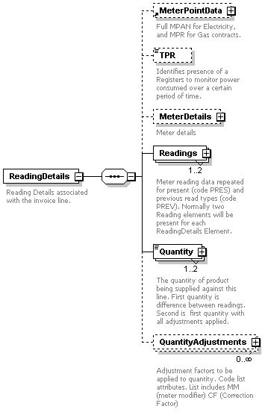

**Description**

Reading Details associated with the invoice line.

**Attributes**

**Code List**

**Example**

**Notes**

|  |  |
| --- | --- |
| **Full Path** | SiteInvoiceLine\ReadingDetails\MeterPointData |
| **Element** | *MeterPointData* |

|  |  |  |  |  |  |
| --- | --- | --- | --- | --- | --- |
| **Relationship with Parent** | Zero-One | **Data Type** | Complex Type | **Mandatory or Optional** | O |



**Description**

Full MPAN for Electricity, and MPR for Gas contracts.

**Attributes**

**Code List**

**Example**

**Notes**

|  |  |
| --- | --- |
| **Full Path** | SiteInvoiceLine\ReadingDetails\TPR |
| **Element** | *TPR* |

|  |  |  |  |  |  |
| --- | --- | --- | --- | --- | --- |
| **Relationship with Parent** | Zero-One | **Data Type** | String | **Mandatory or Optional** | O |

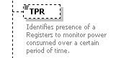

**Description**

TPR of the register. Each reading is linked to a register. Only used in Electricity Invoices.

**Attributes**

**Code List**

**Example**

**Notes**

|  |  |
| --- | --- |
| **Full Path** | SiteInvoiceLine\ReadingDetails\MeterDetails |
| **Element** | *MeterDetails* |

|  |  |  |  |  |  |
| --- | --- | --- | --- | --- | --- |
| **Relationship with Parent** | Zero-One | **Data Type** | Complex Type | **Mandatory or Optional** | O |

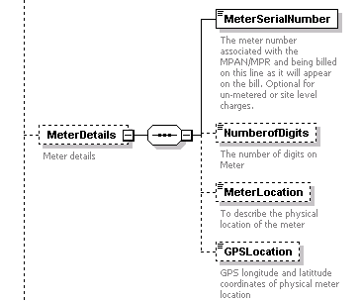

**Description**

Additional meter details

**Attributes**

**Code List**

**Example**

**Notes**

|  |  |
| --- | --- |
| **Full Path** | SiteInvoiceLine\ReadingDetails\MeterDetails\MeterSerialNumber |
| **Element** | *MeterSerialNumber* |

|  |  |  |  |  |  |
| --- | --- | --- | --- | --- | --- |
| **Relationship with Parent** | One-One | **Data Type** | string | **Mandatory or Optional** | M |

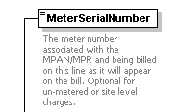

**Description**

The meter number associated with the MPAN/MPR and being billed on this line as it will appear on the bill. Optional for un-metered or site level charges.

**Attributes**

**Code List**

**Example**

**Notes**

|  |  |
| --- | --- |
| **Full Path** | SiteInvoiceLine\ReadingDetails\MeterDetails\NumberofDigits |
| **Element** | *NumberofDigits* |

|  |  |  |  |  |  |
| --- | --- | --- | --- | --- | --- |
| **Relationship with Parent** | One-One | **Data Type** | integer | **Mandatory or Optional** | M |



**Description**

The number of digits on Meter

**Attributes**

**Code List**

**Example**

**Notes**

|  |  |
| --- | --- |
| **Full Path** | SiteInvoiceLine\ReadingDetails\MeterDetails\MeterLocation |
| **Element** | *MeterLocation* |

|  |  |  |  |  |  |
| --- | --- | --- | --- | --- | --- |
| **Relationship with Parent** | Zero-one | **Data Type** | string | **Mandatory or Optional** | O |



**Description**

To describe the physical location of the meter

**Attributes**

**Code List**

**Example**

**Notes**

|  |  |
| --- | --- |
| **Full Path** | SiteInvoiceLine\ReadingDetails\MeterDetails\GPSLocation |
| **Element** | *GPSLocation* |

|  |  |  |  |  |  |
| --- | --- | --- | --- | --- | --- |
| **Relationship with Parent** | Zero-one | **Data Type** | string | **Mandatory or Optional** | O |

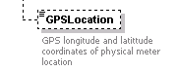

**Description**

GPS longitude and latitude coordinates of physical meter location

**Attributes**

**Code List**

**Example**

**Notes**

|  |  |
| --- | --- |
| **Full Path** | SiteInvoiceLine\ReadingDetails\Readings |
| **Element** | *Readings* |

|  |  |  |  |  |  |
| --- | --- | --- | --- | --- | --- |
| **Relationship with Parent** | One-Two | **Data Type** | Complex Type | **Mandatory or Optional** | M |

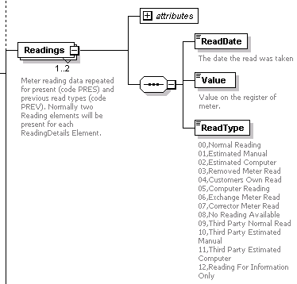

**Description**

Meter reading data repeated for present (code PRES) and previous read types (code PREV). Normally two Reading elements will be present for each ReadingDetails Element.

**Attributes**

Code

**Code List**

**Code - PRES - present**

Code - PREV - previous

**Example**

**Notes**

|  |  |
| --- | --- |
| **Full Path** | SiteInvoiceLine\ReadingDetails\Readings\ReadDate |
| **Element** | *ReadDate* |

|  |  |  |  |  |  |
| --- | --- | --- | --- | --- | --- |
| **Relationship with Parent** | One-One | **Data Type** | Date | **Mandatory or Optional** | M |



**Description**

Date the reading was taken.

**Attributes**

**Code List**

**Example**

**Notes**

|  |  |
| --- | --- |
| **Full Path** | SiteInvoiceLine\ReadingDetails\Readings\Value |
| **Element** | *Value* |

|  |  |  |  |  |  |
| --- | --- | --- | --- | --- | --- |
| **Relationship with Parent** | One-One | **Data Type** | Decimal | **Mandatory or Optional** | M |



**Description**

Value on the register of meter.

**Attributes**

**Code List**

**Example**

**Notes**

|  |  |
| --- | --- |
| **Full Path** | SiteInvoiceLine\ReadingDetails\Readings\ReadType |
| **Element** | *ReadType* |

|  |  |  |  |  |  |
| --- | --- | --- | --- | --- | --- |
| **Relationship with Parent** | Zero-One | **Data Type** | string | **Mandatory or Optional** | O |

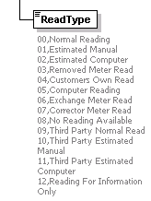

**Description**

Type of reading. Values can only be from the list provided.

**Attributes**

**Code List**

**00,Normal Reading**

**01,Estimated Manual**

**02,Estimated Computer**

**03,Removed Meter Read**

**04,Customers Own Read**

**05,Computer Reading**

**06,Exchange Meter Read**

**07,Corrector Meter Read**

**08,No Reading Available**

**09,Third Party Normal Read**

**10,Third Party Estimated Manual**

**11,Third Party Estimated Computer**

12,Reading For Information Only

**Example**

**Notes**

|  |  |
| --- | --- |
| **Full Path** | SiteInvoiceLine\ReadingDetails\Quantity |
| **Element** | *Quantity* |

|  |  |  |  |  |  |
| --- | --- | --- | --- | --- | --- |
| **Relationship with Parent** | One-Two | **Data Type** | Decimal | **Mandatory or Optional** | M |

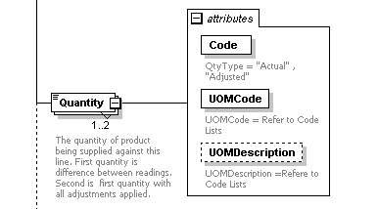

**Description**

The quantity of product being supplied against this line. First quantity is difference between readings. Second is first quantity with all adjustments applied.

**Attributes**

**QtyType**

**UOMCode**

UOMDescription

**Code List**

**QtyType = "Actual" , "Adjusted"**

**UOMCode = Refere to Code Lists**

UOMDescription =Refere to Code Lists

**Example**

**Notes**

|  |  |
| --- | --- |
| **Full Path** | SiteInvoiceLine\ReadingDetails\QuantityAdjustments |
| **Element** | *QuantityAdjustments* |

|  |  |  |  |  |  |
| --- | --- | --- | --- | --- | --- |
| **Relationship with Parent** | Zero-many | **Data Type** | Complex Type | **Mandatory or Optional** | O |

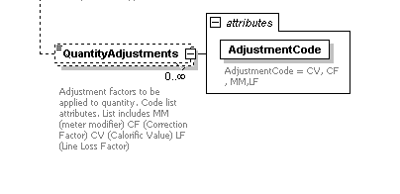

**Description**

**Attributes**

AdjustmentCode

**Code List**

AdjustmentCode = CV, CF, MM, LF

**Example**

<QuantityAdjustments> AdjustmentCode="LF">1.0349</QuantityAdjustments>

**Notes**

|  |  |
| --- | --- |
| **Full Path** | SiteInvoiceLine\ChargeDetails |
| **Element** | *ChargeDetails* |

|  |  |  |  |  |  |
| --- | --- | --- | --- | --- | --- |
| **Relationship with Parent** | Zero-many | **Data Type** | Complex | **Mandatory or Optional** | O |

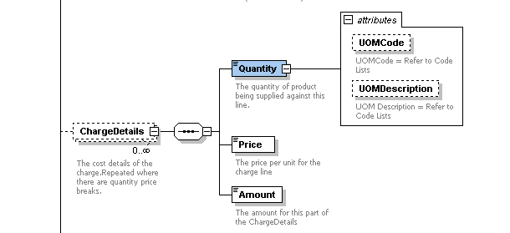

**Description**

The cost details of the charge.

**Attributes**

**Code List**

**Example**

**Notes**

|  |  |
| --- | --- |
| **Full Path** | SiteInvoiceLine\ChargeDetails\Quantity |
| **Element** | *Quantity* |

|  |  |  |  |  |  |
| --- | --- | --- | --- | --- | --- |
| **Relationship with Parent** | one-one | **Data Type** | Decimal | **Mandatory or Optional** | M |

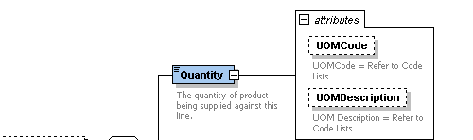

**Description**

The number of units or 'items' of charge to be charged where relevant.

**Attributes**

QuantityType;UOMCode;UOMDescription

**Code List**

**QuantityType:Actual, Adjusted**

UOMCode:Refer to codelist

**Example**

<Quantity QuantityType="ACTUAL" UOMCode="KwH" UOMDescription="KilowattHour">4</Quantity>

**Notes**

**Not all charges have a quantity. The ones for which it applies are:**

**All consumption charges where this is the number of units;**

**CCL (number of units);**

**Availability (Capacity);**

|  |  |
| --- | --- |
| **Full Path** | SiteInvoiceLine\ChargeDetails\Price |
| **Element** | *Price* |

|  |  |  |  |  |  |
| --- | --- | --- | --- | --- | --- |
| **Relationship with Parent** | one-one | **Data Type** | Decimal | **Mandatory or Optional** | M |



**Description**

The price for the charge line.

**Attributes**

**Code List**

**Example**

<Price>0.23453</Price>

**Notes**

|  |  |
| --- | --- |
| **Full Path** | SiteInvoiceLine\ChargeDetails\Amount |
| **Element** | *Amount* |

|  |  |  |  |  |  |
| --- | --- | --- | --- | --- | --- |
| **Relationship with Parent** | one-one | **Data Type** | Currency | **Mandatory or Optional** | M |

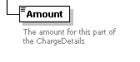

**Description**

The amount for this part of the ChargeDetails

**Attributes**

**Code List**

**Example**

<Amount>132.34</Amount>

**Notes**

|  |  |
| --- | --- |
| **Full Path** | SiteInvoiceLine\LineTotal |
| **Element** | *LineTotal* |

|  |  |  |  |  |  |
| --- | --- | --- | --- | --- | --- |
| **Relationship with Parent** | one-one | **Data Type** | Currency | **Mandatory or Optional** | M |

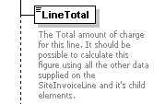

**Description**

The Total amount of charge for this line. It should be possible to calculate this figure using all the other data supplied on the SiteInvoiceLine and it's child elements.

**Attributes**

**Code List**

**Example**

<LineTotal>132.24</Linetotal>

**Notes**

|  |  |
| --- | --- |
| **Full Path** | SiteInvoiceLine\LineTaxCode |
| **Element** | *LineTaxCode* |

|  |  |  |  |  |  |
| --- | --- | --- | --- | --- | --- |
| **Relationship with Parent** | Zero-One | **Data Type** | String | **Mandatory or Optional** | O |

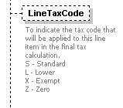

**Description**

To indicate the tax code that will be applied to this line item in the final tax calculation.

**Attributes**

**Code List**

**Invoice Vat Codes**

**S - Standard**

**L - Lower**

**X - Exempt**

**Z - Zero**

**Withdrawn Invoice Vat Codes**

**B - standard**

**M - Lower**

**U - Exempt**

Z - Zero Rate

**Example**

<LineTaxCode>S</LineTaxCode>

**Notes**

|  |  |
| --- | --- |
| **Full Path** | SiteInvoiceLine\SupportingData |
| **Element** | *SupportingData* |

|  |  |  |  |  |  |
| --- | --- | --- | --- | --- | --- |
| **Relationship with Parent** | Zero-many | **Data Type** | Complex | **Mandatory or Optional** | O |

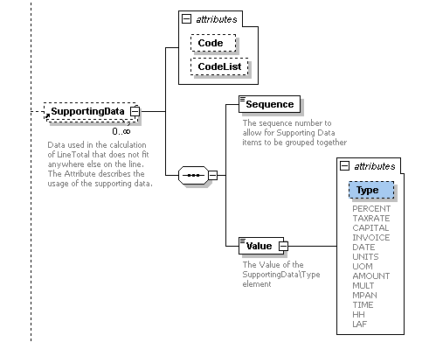

**Description**

Data used in the calculation of LineTotal that does not fit anywhere else on the line. The Attribute describes the usage of the supporting data.

**Attributes**

Code; CodeList

**Code List**

**PERCENT**

**TAXRATE**

**CAPITAL**

**INVOICE**

**DATE**

**UNITS**

**UOM**

**AMOUNT**

**MULT**

**MPAN**

**TIME**

**HH**

LAF

**Example**

**<SupportingData>**

**<Sequence>1</Sequence>**

**<Value Type="LAF">1.00121</Value>**

</SupportingData>

**Notes**

|  |  |
| --- | --- |
| **Full Path** | SiteInvoiceLine\SupportingData\Sequence |
| **Element** | *Sequence* |

|  |  |  |  |  |  |
| --- | --- | --- | --- | --- | --- |
| **Relationship with Parent** | Zero-One | **Data Type** | Integer | **Mandatory or Optional** | O |

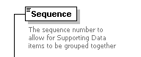

**Description**

The sequence number to allow for Supporting Data items to be grouped together

**Attributes**

**Code List**

**Example**

<Sequence>1</Sequence>

**Notes**

|  |  |
| --- | --- |
| **Full Path** | SiteInvoiceLine\SupportingData\Value |
| **Element** | *Value* |

|  |  |  |  |  |  |
| --- | --- | --- | --- | --- | --- |
| **Relationship with Parent** | one-one | **Data Type** | String | **Mandatory or Optional** | M |

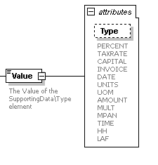

**Description**

The Value of the SupportingData\Type element

**Attributes**

**Code List**

**Example**

<Value Type="DECIMAL">1.099022</Value>

**Notes**

|  |  |
| --- | --- |
| **Full Path** | SiteInvoiceLine\Narrative |
| **Element** | *Narrative* |

|  |  |  |  |  |  |
| --- | --- | --- | --- | --- | --- |
| **Relationship with Parent** | Zero-many | **Data Type** | String | **Mandatory or Optional** | O |

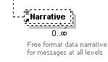

**Description**

Any supporting narrative the supplier may wish to use

**Attributes**

**Code List**

**Example**

<Narrative>To receive more accurate bills did you know you can enter your readings online?</Narrative>

**Notes**

|  |  |
| --- | --- |
| **Full Path** | SiteInvoice\SiteInvoiceFooter |
| **Element** | *SiteInvoiceFooter* |

|  |  |  |  |  |  |
| --- | --- | --- | --- | --- | --- |
| **Relationship with Parent** | One-One | **Data Type** | Complex Type | **Mandatory or Optional** | M |

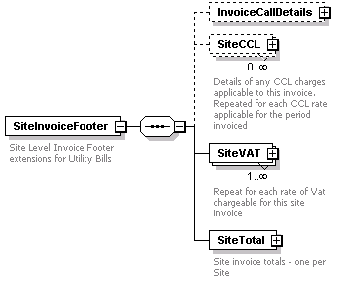

**Description**

Control details associated with this Site Invoice

**Attributes**

**Code List**

**Example**

**Notes**

|  |  |
| --- | --- |
| **Full Path** | SiteInvoice\SiteInvoiceFooter\InvoiceCallDetails |
| **Element** | *InvoiceCallDetails* |

|  |  |  |  |  |  |
| --- | --- | --- | --- | --- | --- |
| **Relationship with Parent** | Zero-Many | **Data Type** | Complex Type | **Mandatory or Optional** | O |

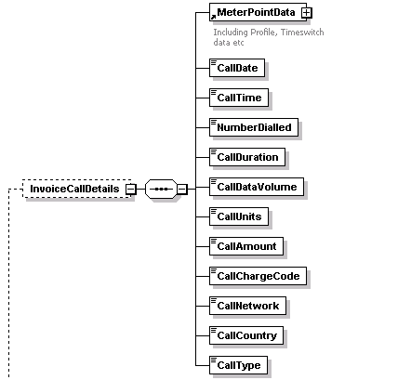

**Description**

For invoices dealing with Mobile Phone Bills, this section contains the call details associated with any call related charges.

**Attributes**

**Code List**

**Example**

**Notes**

|  |  |
| --- | --- |
| **Full Path** | SiteInvoice\SiteInvoiceFooter\InvoiceCallDetails\MeterPointData |
| **Element** | *MeterPointData* |

|  |  |  |  |  |  |
| --- | --- | --- | --- | --- | --- |
| **Relationship with Parent** | Zero-One | **Data Type** | Complex Type | **Mandatory or Optional** | O |



**Description**

Full MPAN for Electricity, and MPR for Gas contracts or Mobile Phone Number. Complex type defined in detail on header element.

**Attributes**

**Code List**

**Example**

**Notes**

|  |  |
| --- | --- |
| **Full Path** | SiteInvoice\SiteInvoiceFooter\InvoiceCallDetails\CallDate |
| **Element** | *CallDate* |

|  |  |  |  |  |  |
| --- | --- | --- | --- | --- | --- |
| **Relationship with Parent** | One-One | **Data Type** | Date (yyyy-mm-dd) | **Mandatory or Optional** | M |



**Description**

Date the call was made

**Attributes**

**Code List**

**Example**

<CallDate>2011-06-20<CallDate>

**Notes**

|  |  |
| --- | --- |
| **Full Path** | SiteInvoice\SiteInvoiceFooter\InvoiceCallDetails\CallTime |
| **Element** | *CallTime* |

|  |  |  |  |  |  |
| --- | --- | --- | --- | --- | --- |
| **Relationship with Parent** | One-One | **Data Type** | Time (HH:MM:SS) | **Mandatory or Optional** | M |



**Description**

Time of the call

**Attributes**

**Code List**

**Example**

**<CallTime>14:20:00-05:00</CallTime>**

**Notes**

|  |  |
| --- | --- |
| **Full Path** | SiteInvoice\SiteInvoiceFooter\InvoiceCallDetails\NumberDialled |
| **Element** | *NumberDialled* |

|  |  |  |  |  |  |
| --- | --- | --- | --- | --- | --- |
| **Relationship with Parent** | One-One | **Data Type** | String | **Mandatory or Optional** | M |



**Description**

The number called

**Attributes**

**Code List**

**Example**

<NumberDialled>1234123456789</NumberDialled>

**Notes**

|  |  |
| --- | --- |
| **Full Path** | SiteInvoice\SiteInvoiceFooter\InvoiceCallDetails\CallDuration |
| **Element** | *CallDuration* |

|  |  |  |  |  |  |
| --- | --- | --- | --- | --- | --- |
| **Relationship with Parent** | One-One | **Data Type** | Integer | **Mandatory or Optional** | M |



**Description**

The duration of the call in 10ths of seconds

**Attributes**

**Code List**

**Example**

<CallDuration>153</CallDuration>

**Notes**

|  |  |
| --- | --- |
| **Full Path** | SiteInvoice\SiteInvoiceFooter\InvoiceCallDetails\CallDataVolume |
| **Element** | *CallDataVolume* |

|  |  |  |  |  |  |
| --- | --- | --- | --- | --- | --- |
| **Relationship with Parent** | Zero-One | **Data Type** | Integer | **Mandatory or Optional** | O |



**Description**

Amount of data transferred for data based calls.

**Attributes**

**Code List**

**Example**

<CallDataVolume>5</CallDataVolume>

**Notes**

|  |  |
| --- | --- |
| **Full Path** | SiteInvoice\SiteInvoiceFooter\InvoiceCallDetails\CallUnits |
| **Element** | *CallUnits* |

|  |  |  |  |  |  |
| --- | --- | --- | --- | --- | --- |
| **Relationship with Parent** | Zero-One | **Data Type** | String | **Mandatory or Optional** | O |



**Description**

**Attributes**

**Code List**

**Example**

<CallUnits>String</CallUnits>

**Notes**

|  |  |
| --- | --- |
| **Full Path** | SiteInvoice\SiteInvoiceFooter\InvoiceCallDetails\CallAmount |
| **Element** | *CallAmount* |

|  |  |  |  |  |  |
| --- | --- | --- | --- | --- | --- |
| **Relationship with Parent** | One-One | **Data Type** | Currency | **Mandatory or Optional** | M |



**Description**

Chargeable amount for the call

**Attributes**

**Code List**

**Example**

<CallAmount>0.15</CallAmount>

**Notes**

|  |  |
| --- | --- |
| **Full Path** | SiteInvoice\SiteInvoiceFooter\InvoiceCallDetails\CallChargeCode |
| **Element** | *CallChargeCode* |

|  |  |  |  |  |  |
| --- | --- | --- | --- | --- | --- |
| **Relationship with Parent** | Zero-One | **Data Type** | String | **Mandatory or Optional** | O |



**Description**

Charge code for example standard rate

**Attributes**

**Code List**

**Example**

<CallChargeCode>STD</CallChargeCode>

**Notes**

|  |  |
| --- | --- |
| **Full Path** | SiteInvoice\SiteInvoiceFooter\InvoiceCallDetails\CallNetwork |
| **Element** | *CallNetwork* |

|  |  |  |  |  |  |
| --- | --- | --- | --- | --- | --- |
| **Relationship with Parent** | One-One | **Data Type** | String | **Mandatory or Optional** |  |



**Description**

The destination network

**Attributes**

**Code List**

**Example**

<CallNetwork>OP1</CallNetwork>

**Notes**

|  |  |
| --- | --- |
| **Full Path** | SiteInvoice\SiteInvoiceFooter\InvoiceCallDetails\CallCountry |
| **Element** | *CallCountry* |

|  |  |  |  |  |  |
| --- | --- | --- | --- | --- | --- |
| **Relationship with Parent** | Zero-One | **Data Type** | String | **Mandatory or Optional** | O |



**Description**

The destination country for the call

**Attributes**

**Code List**

**Example**

<CallCountry>UK</CallCountry>

**Notes**

|  |  |
| --- | --- |
| **Full Path** | SiteInvoice\SiteInvoiceFooter\InvoiceCallDetails\CallType |
| **Element** | *CallType* |

|  |  |  |  |  |  |
| --- | --- | --- | --- | --- | --- |
| **Relationship with Parent** | Zero-One | **Data Type** | String | **Mandatory or Optional** | O |



**Description**

The type of call (voice/data)

**Attributes**

**Code List**

**Example**

<CallType>Data</CallType>

**Notes**

|  |  |
| --- | --- |
| **Full Path** | SiteInvoice\SiteInvoiceFooter\SiteCCL |
| **Element** | *SiteCCL* |

|  |  |  |  |  |  |
| --- | --- | --- | --- | --- | --- |
| **Relationship with Parent** | Zero-Many | **Data Type** | Complex | **Mandatory or Optional** | O |

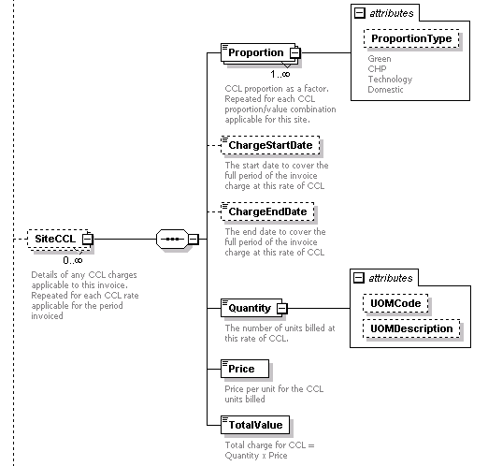

**Description**

Details of any CCL charges applicable to this invoice. Repeated for each CCL rate applicable for the period invoiced

**Attributes**

**Code List**

**Example**

**Notes**

|  |  |
| --- | --- |
| **Full Path** | SiteInvoice\SiteInvoiceFooter\SiteCCL\Proportion |
| **Element** | *Proportion* |

|  |  |  |  |  |  |
| --- | --- | --- | --- | --- | --- |
| **Relationship with Parent** | One-Many | **Data Type** | Complex | **Mandatory or Optional** | O |

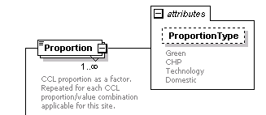

**Description**

CCL proportion as a factor. Repeated for each CCL proportion/value combination applicable for this site.

**Attributes**

ProportionType

**Code List**

**Green**

**CHP**

**Technology**

Domestic

**Example**

**<Proportion ProportionType="CHP">0.3</Proportion>**

**Notes**

|  |  |
| --- | --- |
| **Full Path** | SiteInvoice\SiteInvoiceFooter\SiteCCL\ChargeStartDate |
| **Element** | *ChargeStartDate* |

|  |  |  |  |  |  |
| --- | --- | --- | --- | --- | --- |
| **Relationship with Parent** | Zero-one | **Data Type** | Date (yyyy-mm-dd) | **Mandatory or Optional** | O |

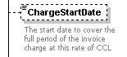

**Description**

The start date to cover the full period of the invoice charged at this rate of CCL

**Attributes**

**Code List**

**Example**

<ChargeStartDate>1967-08-13</ChargeStartDate>

**Notes**

|  |  |
| --- | --- |
| **Full Path** | SiteInvoice\SiteInvoiceFooter\SiteCCL\ChargeEndDate |
| **Element** | *ChargeEndDate* |

|  |  |  |  |  |  |
| --- | --- | --- | --- | --- | --- |
| **Relationship with Parent** | Zero-One | **Data Type** | Date (yyyy-mm-dd) | **Mandatory or Optional** | O |

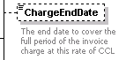

**Description**

The end date to cover the full period of the invoice charged at this rate of CCL

**Attributes**

**Code List**

**Example**

**<ChargeEndDate>1967-08-13</ChargeEndDate>**

**Notes**

|  |  |
| --- | --- |
| **Full Path** | SiteInvoice\SiteInvoiceFooter\SiteCCL\Quantity |
| **Element** | *Quantity* |

|  |  |  |  |  |  |
| --- | --- | --- | --- | --- | --- |
| **Relationship with Parent** | One-One | **Data Type** | Decimal | **Mandatory or Optional** | O |

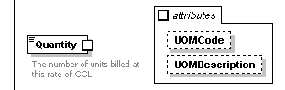

**Description**

The number of units billed at this rate of CCL

**Attributes**

UOM Code, UOM Description

**Code List**

**CUFT**

**KWH**

**KW**

**KV**

**KVA**

**KVAR**

**KVARH**

**SCFH**

**SCMH**

**DAYS**

**HCF**

**KJ**

**LITRES**

**M3**

**MONTHS**

**MSID**

**TCF**

**THERMS**

**THCF**

**TKWH**

**UNITS**

**Example**

**<Quantity UOMCode="KWH" UOMDescription="KiloWattHours" >150</Quantity>**

**Notes**

|  |  |
| --- | --- |
| **Full Path** | SiteInvoice\SiteInvoiceFooter\SiteCCL\Price |
| **Element** | *Price* |

|  |  |  |  |  |  |
| --- | --- | --- | --- | --- | --- |
| **Relationship with Parent** | One-One | **Data Type** | Currency | **Mandatory or Optional** | O |



**Description**

Price per unit for the CCL units billed

**Attributes**

**Code List**

**Example**

<Price>0.0535</Price>

**Notes**

|  |  |
| --- | --- |
| **Full Path** | SiteInvoice\SiteInvoiceFooter\SiteCCL\TotalValue |
| **Element** | *TotalValue* |

|  |  |  |  |  |  |
| --- | --- | --- | --- | --- | --- |
| **Relationship with Parent** | One-One | **Data Type** | Currency | **Mandatory or Optional** | M |



**Description**

Total charge for CCL = Quantity x Price

**Attributes**

**Code List**

**Example**

<TotalValue>8.03</TotalValue>

**Notes**

|  |  |
| --- | --- |
| **Full Path** | SiteInvoice\SiteInvoiceFooter\SiteVAT |
| **Element** | *SiteVat* |

|  |  |  |  |  |  |
| --- | --- | --- | --- | --- | --- |
| **Relationship with Parent** | One-Many | **Data Type** | Complex | **Mandatory or Optional** | M |

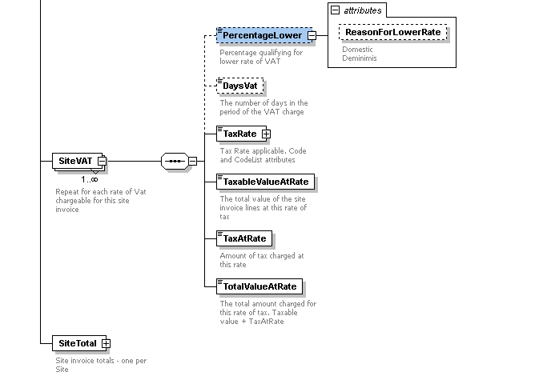

**Description**

Repeated ro each rate of vat applicable for this Site Invoice

**Attributes**

**Code List**

**Example**

**Notes**

|  |  |
| --- | --- |
| **Full Path** | SiteInvoice\SiteInvoiceFooter\SiteVAT\PercentageLower |
| **Element** | *PercentageLower* |

|  |  |  |  |  |  |
| --- | --- | --- | --- | --- | --- |
| **Relationship with Parent** | One-One | **Data Type** | Decimal | **Mandatory or Optional** | O |

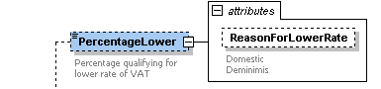

**Description**

The percentage to which a lower rate of VAT applies

**Attributes**

ReasonForLowerVat

**Code List**

**Domestic**

Deminimis

**Example**

**<PercentageLower ReasonForLowerVat="Deminimis">0</PercentageLower>**

**Notes**

|  |  |
| --- | --- |
| **Full Path** | SiteInvoice\SiteInvoiceFooter\SiteVAT\DaysVat |
| **Element** | *DaysVat* |

|  |  |  |  |  |  |
| --- | --- | --- | --- | --- | --- |
| **Relationship with Parent** | Zero-One | **Data Type** | Integer | **Mandatory or Optional** | O |



**Description**

The number of days in the period of the VAT charge

**Attributes**

**Code List**

**Example**

**<DaysVat>30</DaysVat>**

**Notes**

|  |  |
| --- | --- |
| **Full Path** | SiteInvoice\SiteInvoiceFooter\SiteVAT\TaxRate |
| **Element** | *TaxRate* |

|  |  |  |  |  |  |
| --- | --- | --- | --- | --- | --- |
| **Relationship with Parent** | One-One | **Data Type** | String | **Mandatory or Optional** | M |

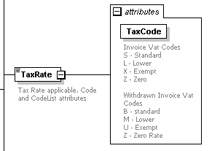

**Description**

The tax rate associated with this charge

**Attributes**

TaxCode

**Code List**

**Invoice Vat Codes**

**S - Standard**

**L - Lower**

**X - Exempt**

**Z - Zero**

**Withdrawn Invoice Vat Codes**

**B - standard**

**M - Lower**

**U - Exempt**

Z - Zero Rate

**Example**

<TaxRate Code="S" CodeList="03">20.0</TaxRate>

**Notes**

|  |  |
| --- | --- |
| **Full Path** | SiteInvoice\SiteInvoiceFooter\SiteVAT\TaxableValueAtRate |
| **Element** | *TaxableValueAtRate* |

|  |  |  |  |  |  |
| --- | --- | --- | --- | --- | --- |
| **Relationship with Parent** | One-One | **Data Type** | Currency | **Mandatory or Optional** | M |

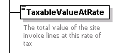

**Description**

The total value of the site invoice lines at this rate of tax

**Attributes**

**Code List**

**Example**

<TaxableValueAtRate>100.00</TaxableValueAtRate>

**Notes**

|  |  |
| --- | --- |
| **Full Path** | SiteInvoice\SiteInvoiceFooter\SiteVAT\TaxAtRate |
| **Element** | *TaxAtRate* |

|  |  |  |  |  |  |
| --- | --- | --- | --- | --- | --- |
| **Relationship with Parent** | One-One | **Data Type** | Currency | **Mandatory or Optional** | M |

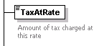

**Description**

The amount of tax charged at this rate

**Attributes**

**Code List**

**Example**

<TaxAtRate>20.00</TaxAtRate>

**Notes**

|  |  |
| --- | --- |
| **Full Path** | SiteInvoice\SiteInvoiceFooter\SiteVAT\TotalValueAtRate |
| **Element** | *TotalValueAtRate* |

|  |  |  |  |  |  |
| --- | --- | --- | --- | --- | --- |
| **Relationship with Parent** | One-One | **Data Type** | Currency | **Mandatory or Optional** | M |

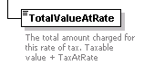

**Description**

The total amount charged at this rate of tax TaxAtRate + TaxableValueAtRate

**Attributes**

**Code List**

**Example**

<TotalValueAtRate>120.00</TotalValueAtRate>

**Notes**

|  |  |
| --- | --- |
| **Full Path** | SiteInvoice\SiteInvoiceFooter\SiteTotal |
| **Element** | *SiteTotal* |

|  |  |  |  |  |  |
| --- | --- | --- | --- | --- | --- |
| **Relationship with Parent** | One-One | **Data Type** | Complex | **Mandatory or Optional** | M |

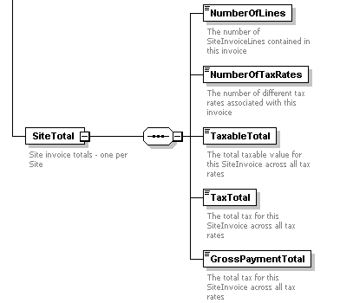

**Description**

Site Invoice totals - one per site invoice

**Attributes**

**Code List**

**Example**

**Notes**

|  |  |
| --- | --- |
| **Full Path** | SiteInvoice\SiteInvoiceFooter\SiteTotal\NumberOfLines |
| **Element** | *NumberOfLines* |

|  |  |  |  |  |  |
| --- | --- | --- | --- | --- | --- |
| **Relationship with Parent** | One-One | **Data Type** | Integer | **Mandatory or Optional** | M |

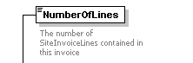

**Description**

The number of SiteInvoiceLines contained in this invoice

**Attributes**

**Code List**

**Example**

**<NumberOfLines>1</NumberOfLines>**

**Notes**

|  |  |
| --- | --- |
| **Full Path** | SiteInvoice\SiteInvoiceFooter\SiteTotal\NumberOfTaxRates |
| **Element** | *NumberOfTaxRates* |

|  |  |  |  |  |  |
| --- | --- | --- | --- | --- | --- |
| **Relationship with Parent** | One-One | **Data Type** | Integer | **Mandatory or Optional** | M |

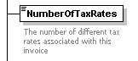

**Description**

The number of different tax rates associated with this invoice

**Attributes**

**Code List**

**Example**

<NumberOfTaxRates>1</NumberOfTaxRates>

**Notes**

|  |  |
| --- | --- |
| **Full Path** | SiteInvoice\SiteInvoiceFooter\SiteTotal\TaxableTotal |
| **Element** | *TaxableTotal* |

|  |  |  |  |  |  |
| --- | --- | --- | --- | --- | --- |
| **Relationship with Parent** | One-One | **Data Type** | Currency | **Mandatory or Optional** | M |

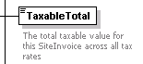

**Description**

The total taxable value for this SiteInvoice across all tax rates

**Attributes**

**Code List**

**Example**

<TaxableTotal>100.00</TaxableTotal>

**Notes**

|  |  |
| --- | --- |
| **Full Path** | SiteInvoice\SiteInvoiceFooter\SiteTotal\TaxTotal |
| **Element** | *TaxTotal* |

|  |  |  |  |  |  |
| --- | --- | --- | --- | --- | --- |
| **Relationship with Parent** | One-One | **Data Type** | Currency | **Mandatory or Optional** | M |

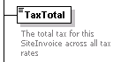

**Description**

The total tax for this SiteInvoice across all tax rates

**Attributes**

**Code List**

**Example**

<TaxTotal>20.00</TaxTotal>

**Notes**

|  |  |
| --- | --- |
| **Full Path** | SiteInvoice\SiteInvoiceFooter\SiteTotal\GrossPaymentTotal |
| **Element** | *GrossPaymentTotal* |

|  |  |  |  |  |  |
| --- | --- | --- | --- | --- | --- |
| **Relationship with Parent** | One-One | **Data Type** | Currency | **Mandatory or Optional** | M |

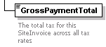

**Description**

The total tax for this SiteInvoice across all tax rates

**Attributes**

**Code List**

**Example**

<GrossPaymentTotal>120.00</GrossPaymentTotal>

**Notes**

Appendix A - Code Lists

|  |  |
| --- | --- |
| **Code List** | *<SiteInvoiceLine><SupportingData>* |
| **Format** |  |

|  |  |  |  |
| --- | --- | --- | --- |
| **Code** | **Format** | **Description** | **Notes or example** |
| PERCENT | Numeric | The interest rate applicable:  Security deposits  Late payment interest  The percentage of MD used in triad estimations  The interest rate applied to the invoice for the Non DD charge |  |
| TAXRATE | Numeric | The Tax rate that applies:  Security deposit interest |  |
| CAPITAL | Numeric | The base amount of money that this charge has used in calculations:  The amount of security deposit on which interest is paid  The balance on which LPI has been charged  The Annual charge for TRIAD estimate |  |
| INVOICE | String | Relevant invoice number or reference  For late payment interest, the invoice for which LPI is being charged  For Collection Fee the invoice on which the fee is charged |  |
| DATE | Date | Relevant date:  For late payment interest, the date the interest began to accrue  For Collection Fee the date of the Interest  For adjustments the invoice period start date for which the adjustent applies  For charges apportioned because of changes of Vat rate, CCL, etc, the date of the start of the charge  Date of Maximum Demand  Date of Half Hour for Triad readings; use the optional SEQ attribute to group the related HH, LAF, Date and Time. |  |
| UNITS | Numeric | Any units used in calculation from other invoices:  For unit/reactive adjustments the number of units adjusted for  For Triad estimate the MD used  For Gas the VOLUME of gas used |  |
| UOM | String | Units of measure of UNITS  Wherever there is a UNITS |  |
| AMOUNT | Numeric | Intermediate or additional prices used in calculations:  For Triad the National grid zonal charge |  |
| MULT | Numeric | Multiplier applied to readings:  For Gas the Correction Factor  For Electricity the Meter Constant or Multiplier |  |
| MPAN | Numeric | Where charges may be applied to only some MPANs on a bill  MPAN number |  |
| TIME | String | Relevant Time:  Time of Maximum Demand  For Triad the Time of the half hour. Use the optional SEQ attribute to group the related HH, LAF, Date and Time. |  |
| HH | Numeric | For Triad readings Half Hour reading for the half hour.  Use the Sequence element to group the related HH, LAF, Date and Time. | EG  <SupportingData>  <Sequence>1</Sequence>  <Value Type="HH">3423</Value>  <SupportingData> |
| LAF | Numeric | LAF value  In the Triad charge the LAF for the half hour; use the Sequence element to group the related HH, LAF, Date and Time. | EG  <SupportingData>  <Sequence>1</Sequence>  <Value Type="LAF">1.0342</Value>  <SupportingData> |

**Appendix B - Triad Example**



**Appendix C - LPI Example**



**Appendix D - Security Deposit Example**



**Appendix E - Bill Example**



**Appendix F - The MPAN**

The MPAN is the 13 character unique reference to a supply. However to the customer, it is shown on their bills as below.

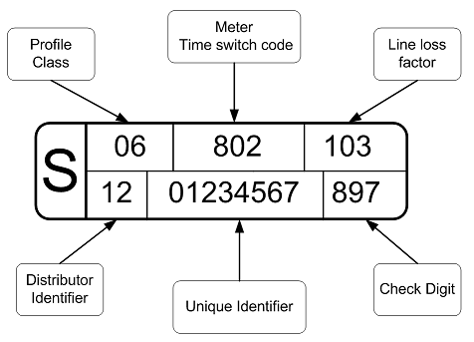

For the purposes of consistancy with the customers bills, the MPAN segment in this XML should be populated in this way. So for the MPAN in the diagram above (plus an SSC code of 0393) it will be represented in the XML as

<MeterPointData>   
 <DistributionIdentifier>12</DistributionIdentifier>  
 <UniqueReference>01234567</UniqueReference>  
 <CheckDigit>897</CheckDigit>  
 <ProfileType>06</ProfileType>  
 <TimeSwitch>802</TimeSwitch>  
 <LineLossFactor>103</LineLossFactor>  
 <SSCCode>0393</SSCCode>  
</MeterPointData>

**Appendix G - File transfer**

**File transfer** is a generic term for the act of transmitting files over a computer network or the Internet. There are numerous ways and protocols to transfer files over a network. Computers which provide a file transfer service are often called file servers. Depending on the client's perspective the data transfer is called uploading or downloading.

There are 2 types of file transfers:

•         Pull-based file transfers where the receiver initiates a file transmission request

•         Push-based file transfers where the sender initiates a file transmission request.

File transfer can take place over a variety of levels:

•         Transparent file transfers over network file systems

•         Explicit file transfers from dedicated file transfer services like FTP or HTTP

•         Distributed file transfers over peer-to-peer networks like Bittorent or Gnutella

•         In IBM Systems Network Architecture, LU 6.2 peer-to-peer file transfer programs such as CA, Inc.'s XCOM Data Transport

•         File transfers over instant messaging or LAN messenger

•         File transfers between computers and peripheral devices

•         File transfers over direct modem or serial (null modem) links, such as XMODEM, YMODEM and ZMODEM.

[For more information about what is accepted as a legal form of invoice/bill sent electronically please visit: http://www.hmrc.gov.uk/vat/managing/charging/e-invoices.htm.](http://www.hmrc.gov.uk/vat/managing/charging/e-invoices.htm)

As the site above mentions there are several ways of sending invoices electronically. You could use:

•       email messages

•       document attachments to emails, such as PDF or XML files

•       secure networks

**Appendix H – Batches**

The BASDA batch envelope can be used to group invoices together for the purposes of transmission. A tax batch trailer is mandatory for these purposes.

**Appendix I – Credit Batches/Credit Notes**

The Batch Trailer should report negative totals where a there is a net credit value for the batch. However, Suppliers should bear in mind that not all financial systems will accept this by default.

Credit notes should always be a complete reversal of the original invoice.

**Appendix J – Consolidated Invoices**

If the supplier requires to send a consolidated invoice, there will be a single BASDA invoice to represent the total value for the consolidated invoice and a BASDA line for each individual site invoice included in the consolidation.

**Appendix K – File Size**

Where invoices are being sent in batches or where there is a consolidated invoice, there can be issues with file sizes for some xml parsers.